Prerequisite IBM Cloud Service

|  |  |
| --- | --- |
| Date | 01 November 2022 |
| Team ID | PNT2022TMID42038 |
| Project Name | Project – IOT Based Real – time River Water Quality Monitoring and Control  System |
| Maximum Marks | 4 Marks |

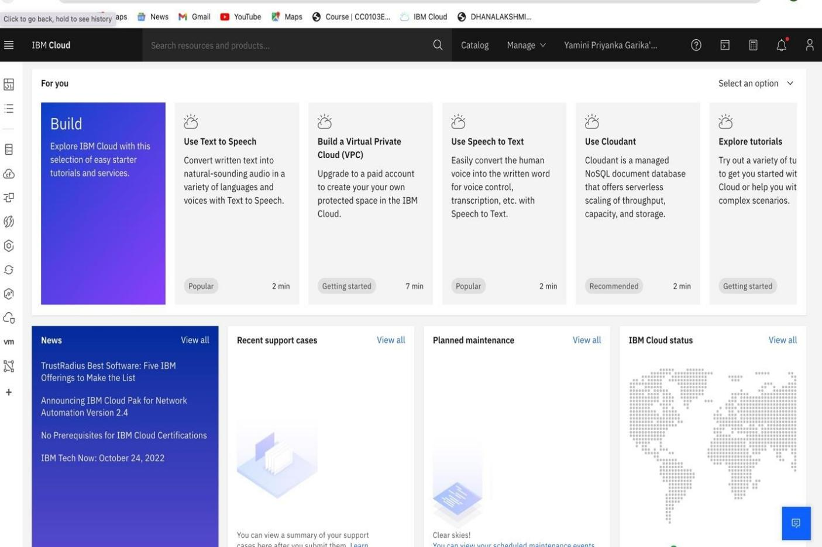IBM Account Dashboard